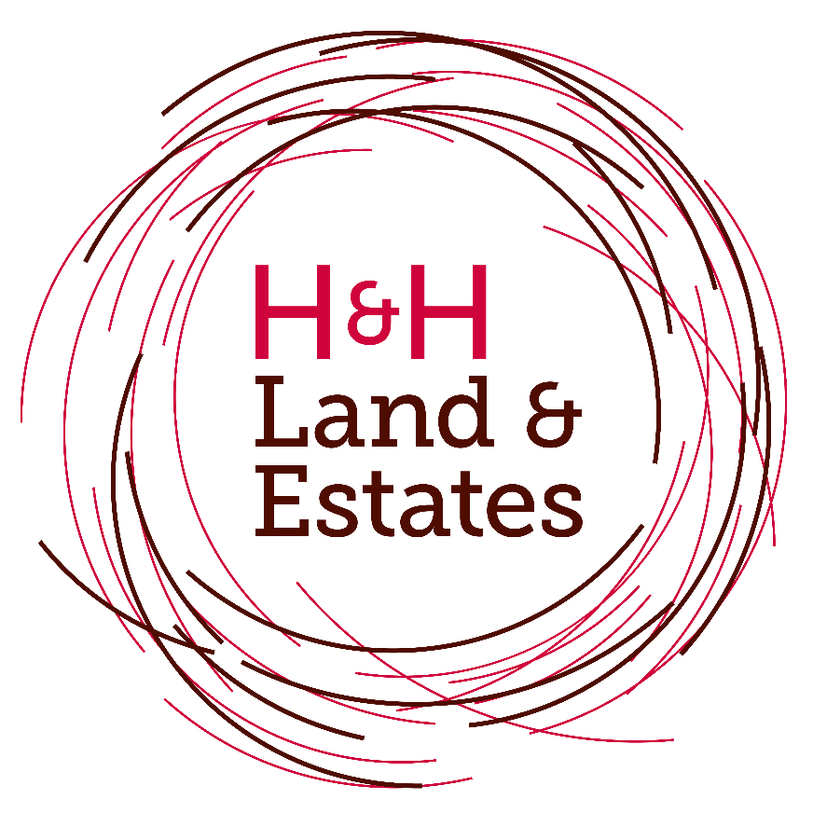

Breakfast Roll Promotion Terms & Conditions:
1. The offer is open to individuals aged 18 years or over, excluding employees of H&H Land & Estates and members of their immediate families.
2. Only one voucher may be claimed per person during the promotional period.
3. No purchase is necessary.
4. The promotion will run throughout 2026. Anyone who completes the H&H Land & Estates enquiry form with their contact details and indicates the services they are interested in will receive one voucher for either a Bacon or Sausage Sandwich, redeemable at the St Boswells Mart Cafe, subject to availability.
5. Vouchers are non-transferable, non-refundable and cannot be exchanged for cash or any alternative.
6. Fraudulent, illegible, incomplete or incorrectly completed forms will not qualify for the offer.
7. By completing the form, you consent to H&H Land & Estates contacting you regarding the services you have expressed interest in. Your personal information will be processed in accordance with the H&H Land & Estates Privacy Policy.
8. H&H Land & Estates reserves the right to withdraw or amend this promotion at any time without prior notice where necessary due to circumstances beyond its reasonable control.
H&H Land & Estates Ltd.

